**UK DIAGNOSTIC IMAGING DEVICES MARKET**

According to Intelli, the UK diagnostic imaging devices market was valued at USD 1,840 million in 2024 and is projected to reach USD 2695.61 million by 2032, growing at a CAGR of 5.79% from 2024 to 2032.

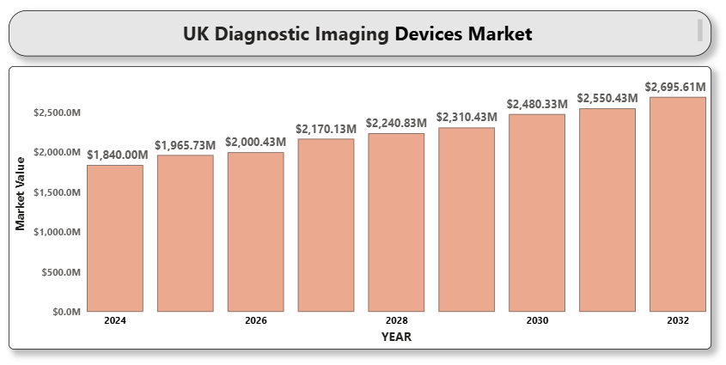

The UK diagnostic imaging devices market is witnessing stable growth due to increasing demand for early and accurate diagnosis, technological innovations in imaging modalities, and the rising prevalence of chronic diseases such as cancer, cardiovascular, and neurological disorders. The National Health Service (NHS) has also been a key driver through large-scale investments in modernizing imaging infrastructure, particularly in underserved areas. The integration of artificial intelligence (AI), 3D imaging, and portable systems into diagnostic workflows is enabling faster and more precise diagnostic capabilities. Additionally, partnerships between private providers and the NHS are expanding imaging accessibility and reducing patient wait times.

**UK Diagnostic Imaging Devices Market Definition**

Diagnostic imaging devices are medical instruments used to create visual representations of the internal structures of the body for clinical analysis and medical intervention. These include X-ray machines, CT scanners, MRI systems, ultrasound devices, nuclear imaging equipment (PET and SPECT), and mammography systems. The primary purpose of these devices is to diagnose diseases, monitor treatment progress, and guide surgical procedures. These devices are used across hospitals, diagnostic imaging centers, ambulatory surgical centers, and academic research settings. Advancements in digital imaging, miniaturization, and AI integration are enhancing the performance, accuracy, and accessibility of diagnostic imaging in the UK.

**UK Diagnostic Imaging Devices Market Overview**

The diagnostic imaging devices market in the UK continues to expand due to a combination of technological advancements, increasing healthcare demand, and supportive public health policies. The growing geriatric population and the rising burden of chronic illnesses are amplifying the need for effective diagnostic solutions. In addition, early screening programs for diseases such as breast cancer and cardiovascular conditions are boosting the adoption of imaging modalities such as mammography and cardiac MRI.

However, the market also faces several challenges. Equipment procurement delays, workforce shortages, and uneven access to diagnostic services across the UK regions can limit market growth. Despite these issues, the government's continued focus on NHS reforms and digitization is expected to propel the market forward, particularly with AI-powered imaging platforms, mobile diagnostics, and integrated radiology networks gaining momentum.

**Market Segmentation by Product Type:**

• X-ray Imaging Systems

• Computed Tomography (CT) Scanners

• Magnetic Resonance Imaging (MRI) Systems

• Ultrasound Systems

• Nuclear Imaging Systems (PET/SPECT)

• Mammography Systems

• Others

Among product types, CT and MRI systems remain the most commonly installed modalities in the UK, driven by their wide application scope in neurological, oncological, and orthopedic diagnostics. Ultrasound systems are also widely adopted due to their non-invasive and cost-effective nature, especially in maternity and general practice.

**Market Segmentation by Application:**

• Cardiology

• Oncology

• Neurology

• Orthopedics

• Obstetrics & Gynecology

• Other Applications

The oncology segment dominates the UK market, owing to the increasing incidence of cancer and the use of diagnostic imaging in screening, staging, and monitoring. Neurology and cardiology segments are also growing steadily due to a high burden of stroke and cardiovascular conditions.

**Market Segmentation by End User:**

• Hospitals

• Diagnostic Imaging Centers

• Research and Academic Institutes

Hospitals remain the largest end-user segment, benefiting from NHS funding and infrastructure. Diagnostic imaging centers are growing rapidly due to increasing outsourcing of diagnostic services by hospitals and private healthcare expansions.

**Market Segmentation by Region:**

• England

• Scotland

• Wales

• Northern Ireland

England dominates the UK imaging devices market due to its larger healthcare infrastructure and budget. However, the other regions are seeing increased investment in mobile and digital imaging to address regional healthcare inequalities.

**Key Players**

This report includes detailed profiling and benchmarking of leading companies including GE HealthCare, Siemens Healthineers AG, Koninklijke Philips N.V., Canon Medical Systems Corporation, FUJIFILM Holdings Corporation, Hologic Inc., Samsung Medison Co. Ltd., and Shimadzu Corporation. Each profile includes company background, financial performance, product portfolio, and recent developments.

**Key Developments**

• In March 2023, GE HealthCare announced the launch of the SIGNA PET/MR AIR, its latest high-performance hybrid system combining PET and MRI in a single scan.

• In May 2023, Siemens Healthineers partnered with the NHS England to expand AI-based chest X-ray diagnostic tools in public hospitals.

• In January 2024, FUJIFILM opened a new diagnostics research facility in the UK aimed at improving early cancer detection through advanced CT imaging.

**Market Attractiveness**

The UK diagnostic imaging devices market remains highly attractive due to strong healthcare infrastructure, rising disease prevalence, and rapid adoption of innovative technologies. Increased investment in AI-driven imaging, point-of-care solutions, and remote diagnostics A close-up of hands holding a tablet and a pen
present new avenues for market players. Additionally, the government’s commitment to reducing diagnostic waiting times and expanding mobile screening programs enhances the growth potential. Favorable reimbursement frameworks and the prioritization of early disease detection in national healthcare policy also contribute to the attractiveness of this market.

**Porter’s Five Forces**

• Threat of New Entrants: Moderate. Regulatory approvals, capital intensity, and the need for specialized technology create significant barriers. However, the rise of AI-driven imaging startups and partnerships with healthtech platforms are lowering the entry barriers for niche innovations.

• Bargaining Power of Suppliers: Low to moderate. While core component suppliers (e.g., semiconductors, superconductors) have limited availability, the presence of multiple global vendors dilutes their power. Larger imaging companies often have long-term procurement agreements, reducing supplier leverage.

• Bargaining Power of Buyers: High. NHS procurement exerts significant control over purchasing terms, volumes, and prices. Buyers also demand bundled services, warranties, and upgrades, enhancing their bargaining position.

**TABLE OF CONTENTS**

1. **INTRODUCTION OF UK DIAGNOSTIC IMAGING DEVICES MARKET**1.1 Overview of the Market   
   1.2 Scope of Report   
   1.3 Assumptions
2. **EXECUTIVE SUMMARY**
3. **RESEARCH METHODOLOGY**3.1 Data Mining   
   3.2 Validation   
   3.3 Primary Interviews   
   3.4 List of Data Sources
4. **UK DIAGNOSTIC IMAGING DEVICES MARKET OUTLOOK**4.1 Overview   
   4.2 Market Dynamics   
   4.2.1 Drivers    
   4.2.2 Restraints    
   4.2.3 Opportunities    
   4.2.4 Trends    
   4.3 Porters Five Force Model   
   4.4 Value Chain Analysis
5. **UK DIAGNOSTIC IMAGING DEVICES MARKET, BY PRODUCT TYPE**5.1 X-ray Imaging Systems   
   5.2 Computed Tomography (CT) Scanners   
   5.3 Magnetic Resonance Imaging (MRI) Systems   
   5.4 Ultrasound Systems   
   5.5 Nuclear Imaging Systems (PET/SPECT)   
   5.6 Mammography Systems   
   5.7 Others
6. **UK DIAGNOSTIC IMAGING DEVICES MARKET, BY APPLICATION**6.1 Cardiology   
   6.2 Oncology   
   6.3 Neurology   
   6.4 Orthopedics   
   6.5 Obstetrics  & Gynecology  
   6.6 Other Applications
7. **A close-up of hands holding a tablet and a pen

   Description automatically generatedUK DIAGNOSTIC IMAGING DEVICES MARKET, BY END USER**7.1 Hospitals   
   7.2 Diagnostic Imaging Centers   
   7.3 Ambulatory Surgical Centers   
   7.4 Research and Academic Institutes
8. **UK DIAGNOSTIC IMAGING DEVICES MARKET, BY REGION**8.1 England   
   8.2 Scotland   
   8.3 Wales   
   8.4 Northern Ireland
9. **UK DIAGNOSTIC IMAGING DEVICES MARKET COMPETITIVE LANDSCAPE**9.1 Overview   
   9.2 Company Market Ranking   
   9.3 Key Development Strategies
10. **COMPANY PROFILES  
    10.1 GE HealthCare**10.1.1 Overview    
    10.1.2 Financial Performance    
    10.1.3 Product Outlook    
    10.1.4 Key Developments    
    **10.2 Siemens Healthineers AG**10.2.1 Overview    
    10.2.2 Financial Performance    
    10.2.3 Product Outlook    
    10.2.4 Key Developments    
    **A close-up of hands holding a tablet and a pen

    Description automatically generated10.3 Koninklijke Philips N.V.**10.3.1 Overview    
    10.3.2 Financial Performance    
    10.3.3 Product Outlook    
    10.3.4 Key Developments    
    **10.4 Canon Medical Systems Corporation**10.4.1 Overview    
    10.4.2 Financial Performance    
    10.4.3 Product Outlook    
    10.4.4 Key Developments    
    **10.5 FUJIFILM Holdings Corporation**10.5.1 Overview    
    10.5.2 Financial Performance    
    10.5.3 Product Outlook    
    10.5.4 Key Developments    
    **10.6 Hologic Inc.**10.6.1 Overview    
    10.6.2 Financial Performance    
    10.6.3 Product Outlook    
    10.6.4 Key Developments    
    **10.7 Samsung Medison Co. Ltd.**10.7.1 Overview    
    10.7.2 Financial Performance    
    10.7.3 Product Outlook    
    10.7.4 Key Developments    
    **10.8 Shimadzu Corporation**10.8.1 Overview    
    10.8.2 Financial Performance    
    10.8.3 Product Outlook    
    10.8.4 Key Developments
11. **A close-up of hands holding a tablet and a pen

    Description automatically generatedKEY DEVELOPMENTS**11.1 Product Launches/Developments   
    11.2 Mergers and Acquisitions   
    11.3 Business Expansions   
    11.4 Partnerships and Collaborations
12. **APPENDIX**12.1 Related Research